Account number | PO number | Date Required | Date | Page 1 of

KEY INTERLOCKING
A Division of Performance Innovations Ltd.
108 - 7073 Venture Street , Delta,
British Columbia Canada, V4G 1H8
Tel: 604-940-0068 Fax: 604-940-1047
www.keyinterlocking.com
Email: sales@keyinterlocking.com

Bill to |  | Ship to |  |  | Purchasing Agents Name |  | End User
 |  |  |  | Name
 |  |  |  | Phone
 |  |  |  | Fax #

Ordering Guide
A. Lock Type | B. # of Cylinders | C. Plunger length  In withdrawn position |  | D. Bolt  Orientation | E. Key Removable  Position | F. # of Cylinders “W”  for Multiple Cylinders | G. Options | H. Key Interchange
VF -flat mount  VB -base mount  VD -door mount  VN -narrow mount  VT -transfer block  VC -camlock  CM -cylinder mount  VP - padlock | 1-9 for up to 9 cylinders.  Use A for 10  B for 11  C for 12  D for 13  E for 14  F for 15 | 000  025  037  050  062  075  100  125  137  150  200  300 | 0” 0mm  1/4” 6.4mm  3/8” 9.5mm  1/2” 12.7mm  5/8” 15.8mm  3/4 19.1mm  1” 25.4mm  1-1/4” 31.7mm  1-3/8” 34.9mm  1-1/2” 38.1mm  2” 50.8mm  3” 76.2mm | L (bolt left)  or  R (bolt right)  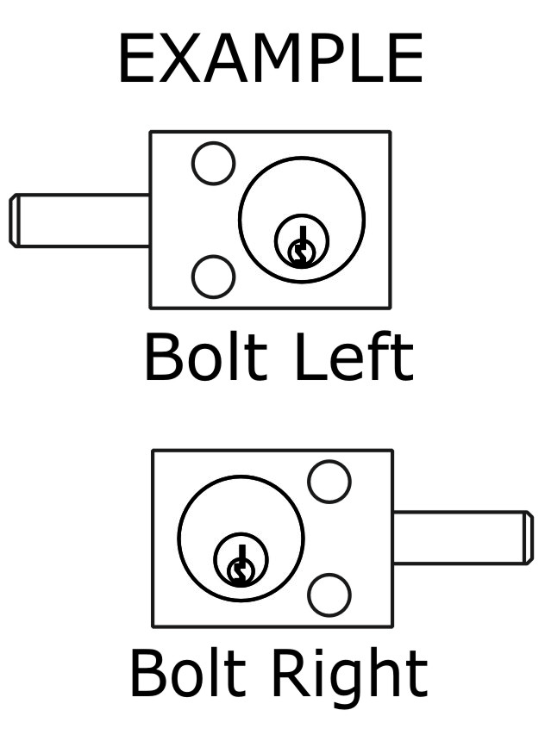 | For single cylinder locks, key can be removable  “E” (extended)  or  “W“ (withdrawn)  For multi cylinder locks  “E” (extended)  Multi cylinder locks always begin with first cylinder “E” | -Leave blank for single  Cylinder locks.  -For multiple cylinder locks  list the number of “W”  (withdrawn) cylinders  -Multi cylinder locks always  begin with first cylinder “E”  Examples of three cylinder locks  EEE select 0 for 0 withdrawn  EEW select 1 for 1 withdrawn  EWW select 2 for 2 withdraw  A for 10 , B for 11 etc. | S Switch 1no 1nc  D Dust cover  5DC .500 Door Catch  25DC .250 Door Catch  ADP VD Adapter  RP Roll Pin | Examples  A1  A2  B1  B2

 |  | Part Number
Item  # | Qty | A | B | C | D | E | F | G | H  Key Interchange | Remarks | Unit Price | Amount
1
2
3
4
5
6
7
8

 |  | Part Number |  |  |  |  |  |  |  |  | Page 2 of 2
Item  # | Qty | A | B | C | D | E | F | G | H  Key Interchange | Remarks | Unit Price | Amount
9
10
11
12
13
14
15
16
17
18
19
20
21
22
23
24
25
26
27
28
29
30
31
32
33
34
35
36
37
38
39
40

